Project Report Template

1. **INTRODUCTION** 
   1. Overview

TITLE : Vehicle management using salesforce

* It is the application used to choose cars,bikes and other vehicles for travel.

1.2 purpose

* It is a manegment software that allows customer vehicle buying (nature) capacity.

**2 Problem Definition & Design Thinking**

2.1 empathy map 2.2 Ideation & Brainstorming map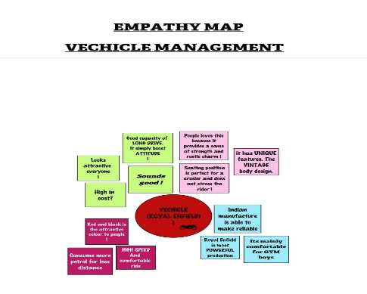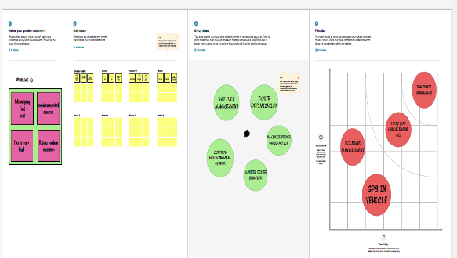

1. **RESULT**

* 1. Data Model:

|  |  |  |  |
| --- | --- | --- | --- |
| OBJECTS | Account | Vehicles | Drivers |
| FIELD 1 | Customer name | Vehicles types | Driver name |
| FIELD 2 | Customer mob. No. | Vehicles name | Licence number |
| FIELD 3 | Customer  Address: | Vehicle number | Fair per hour |
| FIELD 4 | Personal ID: | condition | Mobile number |

**Activity & Screenshot**

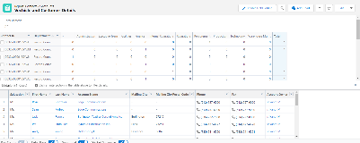Attach the screenshots of your project activity along with the description.

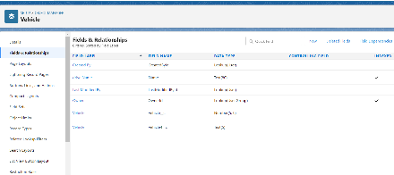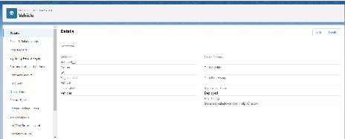

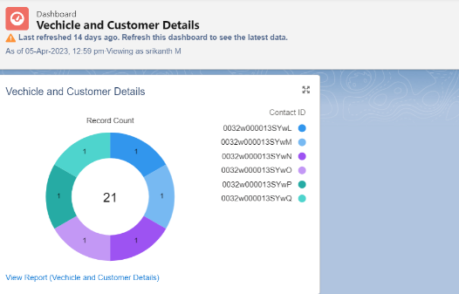

1. **Trailhead Profile Public URL**

**Team Lead** - https://trailblazer.me/id/nkumar2936

**Team Member 1 - https://trailblazer.me/id/srikm16**

**Team Member 2 - https://trailblazer.me/id/sanjm35**

**Team Member 3 – https://trailblazer.me/id/seran18**

1. **ADVANTAGES & DISADVANTAGE**

* It gives vehicle buying nature of the customer.

&

* Need skills based for oprating vehicle managment software system.

1. **APPLICATIONS**

* It helps to fund customer buying nature of vehicles.
* It is used to analyse the future product requrements.

1. **CONCLUSION**

* The vehicle management software system helps to reduce the risk management ,analys the product need for better selling.

1. **FUTURE SCOPE**

* This technology is used in business operation , coudinate the workforce of labours and helps in business management for profit